Terms & Conditions

FESTIVE OFFER

- Details of the festive offer are as below

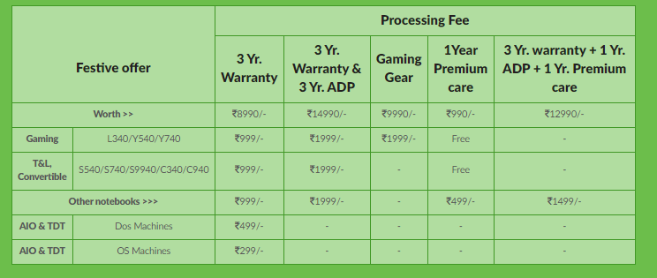

- Festive offer is valid only on below mentioned series

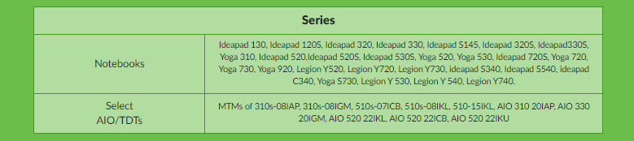

- Once the eligible model has been purchased, the customer needs to visit https://buyalenovo.com/offerRedemption.html and enter details of the purchased product and submit details.
- Customer can reach out to Offer Helpline - 080-49064431 in case of any redemption issues.
- Offer is valid till 30th November
- The 3 year warranty is including 1 year onsite and 2 years of additional warranty. And Customers registering for 3 Years of ADP can claim ADP once in 1 year for 3 years.
  - For customers who claim the warranty offers (Total of 3 years warranty (including 1 year base warranty)/ 3 year ADP & Premium Care) a soft copy of the warranty certificate will be emailed to the customer within 11 working days from the payment receipt. And Courier based offer will be fulfilled within 45 working days from the payment receipt.
- Select MTMs (models) of above products are only eligible to avail Lenovo Festive Offer. For detailed MTM wise eligibility, please check on www.buyalenovo.com/redeem for offers applicable.
- Please refer to complete terms and conditions on https://www.lenovo.com/in/en/festive-offers/

EASE MY TRIP OFFER

  - To avail discounts, users have to book Flight as per their preference by applying coupon code.
  - Rs. 800 off on Round Trip (Flight Booking) Minimum booking amount Rs. 3000
  - Rs. 700 off on Hotel booking (Minimum booking amount Rs. 4000)
  - Rs. 1000 off on domestic holidays (Minimum booking amount Rs 40,000)
  - Rs 2000 off on International holidays(Minimum booking amount Rs 75000)
  - Offer valid on Flights, Hotel & holidays bookings.
  - Coupon will be received within 30 days after delivery of laptop on the email address of the customer
  - The coupon received can be redeemed till 31st December 2019.
  - Convenience fees will be charged as per the applicability.
  - The offer is valid for bookings made on EaseMyTrip's website, Mobile site, Android & iOS App
  - This offer cannot be clubbed with any other offer running on EaseMyTrip.
  - Bookings with the valid promo codes will be only eligible for this offer.
  - One user can avail offer only for once.
  - Valid for all users.
  - This offer cannot be clubbed with any other offer running on EaseMyTrip
  - In case of partial/full cancellation the offer stands void and discount will be rolled back before processing the refunds.
  - Child / infant discount, date or flight change, refund charges, weekend surcharge, black out period, travel restrictions and / or flight restriction will be also applicable as per the fare rule
  - Changes in flights, hotels & bus dates are allowed with change fees and fare difference
  - Changes in names are not allowed
  - In the event of any misuse or abuse of the offer, EaseMyTrip reserves the right to deny the offer to the customers.
  - EaseMyTrip is the sole authority for interpretation of these terms.
  - In addition, EaseMyTrip standard booking and privacy policy on EaseMyTrip.com shall apply.
  - In the event of any dispute, Courts of New Delhi will have jurisdiction.
  - EaseMyTrip reserves the right, at any time, without prior notice and liability and without assigning any reason whatsoever, to add/alter/modify/change or vary all of these terms and conditions or to replace, wholly or in part, this offer by another offer, whether similar to this offer or not, or to extend or withdraw it altogether.
  - EaseMyTrip shall not be liable for any loss or damage arising due to force majeure.
  - For any queries, please write to lenovo@ndslindia.com

